STATISTICS

What is Statistics?

It is a branch of science whose remit involves the enqiry into the state of some entity. This involves the application of a typical scientific method such as that illustrated in the figure below:

Identification

Formulation

Modelling

Testing &
Validation

Implementation

Statistics is the science of uncertainty. It gives a scientific and hence a rational methodology with which to understand variability. Elements in statistics are :

- Information Collection

- Information Summaries

- Information Analysis

- Information Modelling

- Information Inferences

- Information Forecasting

“Statistics deals with the collection and analysis of data to solve real-world problems; it is the science and art of obtaining and analysing data. Of course, all engineers engage in such activities; so all engineers deal with statistics. What makes the dicipline of statistics useful and unique is that it is concerned with the process of variability. That is statistical methods are concerned with ways to deal with variability.”

Hogg and Ledolter (19XX)

Information can be in the form of pictures, words, music, electrical signals or numbers. The use of numbers is the most familiar in statistics and this type of quantitative data can be classified into the categories of variables or attributes.

Variables are continuous measurements such as weight, height or speed or discrete variables like number of children per family, or number of cars owned. Attribute data is simply a recording of a state, for example married or single, or defective - non defective. Attribute data can also be expressed as counts of the numbers in different states. An example of this could be the number of things wrong with a new house.

Why Use Statistics?

There is a need to know:

i. how the process is performing.

ii. Can improvements be made.

iii. if improvements are worthwhile.

iv. Convince others of the need for change.

Statistics provides a methodology for this. Specifically, statistics allows us to:

• collect data

• measure

• summarise

• identify relationships

• make inferences and predict

• facilitate communication

The application of statistics makes for timely, efficient and accurate investigation and reporting.

Statistics has been described as a "vital business tool" and Cristoforio (1987) states that:

"Words can't describe quality - only statistics can"

Edward Deming in his 1986 book “Out of the Crisis” states:

“Statistics is the science of variation and is the only way to truly understand quality”

What is Variation?

Everything varies and the greater this variation the greater the uncertainty. The aim in the area of quality is to firstly identify the amount of variation, and then control it to within acceptable bounds and then reduce variation and hence improve.

How Does Variability Come About?

Everything varies: no two things are precisely the same - if measured sufficiently accurately there are always differences. These natural variances are often greatly inflated when humans are involved - particularly when they manufacturing goods or providing services. Many factors impinge on the “production” system which increase natural variability, such as economic and environmental fluctuations, peoples' state of health and emotions, raw materials used, condition of equipment used and so forth.

Variability exists everywhere

PROCESS

Input
Customer

WIDER SYSTEM
Society
Economy
Environment
Competition
Technology

For the processes that you are involved with list six things that can vary and how this variability can be detected:

Types of Variation

Variation can be classified into two types assignable causes and common causes. In the case of assignable causes, variation, usually excessive, can be attributed to a reason such as a machine is broken, a photocopier is low on toner, or extreme weather conditions. Often assignable cause variation can be dealt with easily. Common cause variation is harder to reduce and is the natural or background variation of the process. To reduce this type of variation, a long sustained effort to improve quality must be undertaken. Statistical quality methods can help with this and a large commitment of both management and staff is required.

The aim is to reduce this variability and produce consistency and therefore make the process ROBUST to the inherent variation. It is precision rather than accuracy that is required. Consider the performance of the following two sharp shooters - who has the best long term prospect and why?

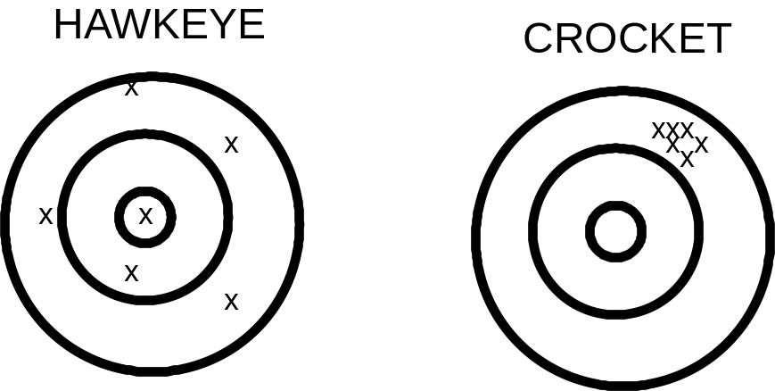

Statistics is a "tool" which can be used to obtain both robustness and precision.
There is an over riding principle that one should remember - simple methods are best. Not only are they often the most appropriate, but they are often more believable, understandable and easier to communicate. The Americans call this the KISS principle

KEEP IT SIMPLE STUPID!!

Exercise on Variability

Examine the seige catapult. Fire a stone and measure its distance. Now positionthe catapult that distance from the castle.

Do you think it will fire a stone and hit the castle?

Fire the stone and then move the catapult to correct for any over or under inaccuracy.
Repeat this eleven times, rcording the distances.

Now work out the difference between the shortest and furthest distances, (this measurement is called the range).

Now leave the catapult in one place and fire it a dozen or so times and work out the range.

What do you conclude?

This Course

The course has been designed to give an awareness of the usefulness of various statistical tools that may be of help to you at your work. It is by no means comprehensive, but most of the main methods which will be of use to you will be covered. The course will begin with the assumption that you have collected data and some tools for presenting this and summarising it will be given. The concept of probability will then be outlined and some useful distributions described. This will then allow the consideration of confidence in estimates and judgements made as to the significance of differences. After this we will then consider the earlier stage of data collection and methods of enhancing accuracy in decision making. After this, a review of tools particulary helpful in the improvement of quality will be presented and the course will finish with an overview of the concepts of correlation and regression.

The course material is just in the form of notes and fuller treatment of the topics covered are to be found in the texts listed at the end of the notes.

CHAPTER TWO

Data Presentation and Summaries

GRAPHICAL TOOLS ARE VERY HELPFUL IN IDENTIFYING PROBLEMS
There now follow some examples of charts which can be used:

SCATTER PLOTS

Simple plots can be very useful in identifying relationships. For example is there a relationship between temperature and the percentage of prepacked food failing a bacteria incubation test.

Temperature | 27 | 30 | 31 | 32 | 32 | 32.5 | 32.5 | 32.5 | 33 | 33
% Failing | 1 | 4 | 7.5 | 8 | 4.5 | 7 | 5 | 9 | 11 | 13

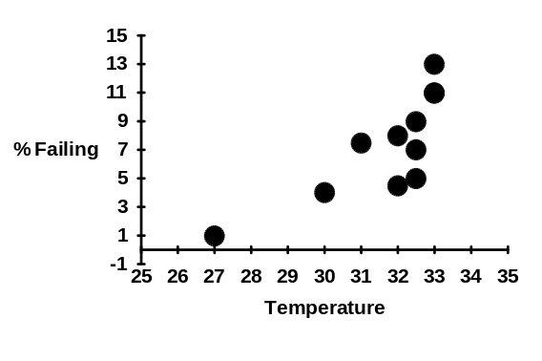

So the percentage failing and temperature do seem to be related - they are said to be positively correlated.

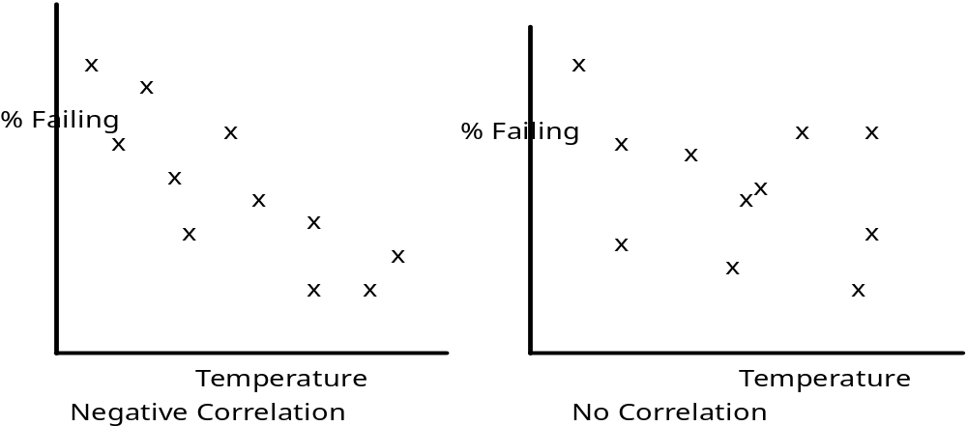
RUN PLOTS

These are very useful for identifying trends, like for
example the temperature in a controlled room over a 65 day period:

There appears to be a gradual downwards drift (trend).

Run plots are also useful for identifying assignable causes. For example, consider the following plot of weekly total defects in sending invoices:

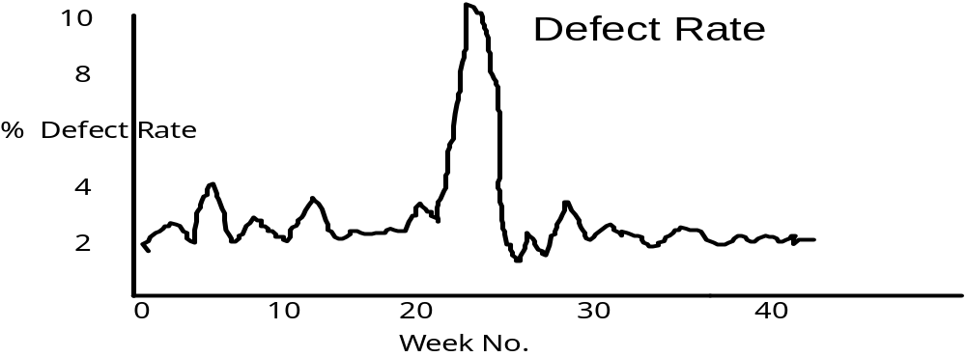

What could be the reasons for the dramatic rise in the defect rate?
PIE CHARTS AND BAR CHARTS

These are useful for displaying attribute data. For example consider a survey of 155 cars manufactured in three countries. The distribution of these cars by country of origin is shown in the following diagrams:

Pie Chart of Origin of Cars

Bar Chart of Origin of Cars

The pie chart looks nice, but it is hard to construct and is not nearly as informative as the bar chart. The more categories then the more appropriate bar charts become.

In the next chapter more formal ways of picturing data is described. In addition to this numerical summaries of data are outlined and the methodology of exploratory data analysis is introduced.
Data Summaries

Graphical

In this chapter pictorial and numerical summaries of data will be described and the chapter will end by outlining the powerful technique of Exploratory Data Analysis.

When describing data the key pieces of information to convey are their LOCATION and SPREAD. By LOCATION we mean location on the number line, for example the numbers 5, 3, 4, 2, 8, 4 are located at different place from the numbers 100 110, 90, 98, 130.

SPREAD is a critical measure for qualty - it is a measure of the data's variability. The larger the spread, the greater the variability and so, in quality terms, the poorer the performance.

Thus to compare a process at different times or with other processes it is necessary to have measures of the location and spread of the associated data.

Consider the following three data sets of miles per gallon of American, European and Japanese cars recorded as part of a survey in 1987. The data is :

Row | mpg | make | origin | model | price.
1 | 43.1 | Volkswagen | 2. | Rabbit Dl | 2400
2 | 36.1 | Ford | 1. | Fiesta | 1900.
3 | 32.8 | Mazda | 3. | GLC Deluxe | 2200.
4 | 39.4 | Datsun | 3. | B210 GX | 2725.
5 | 36.1 | Honda | 3. | Civic CVCC | 2250.
6 | 19.9 | Oldsmobile | 1. | Cutlass | 3300.
7 | 19.4 | Dodge | 1. | Diplomat | 3125.
8 | 20.2 | Mercury | 1. | Monarch | 2850.
9 | 19.2 | Pontiac | 1. | Phoenix | 2800.
10 | 20.2 | Ford | 1. | Fairmont A | 2375.
12 | 25.1 | Ford | 1 |  | 2700.
14 | 19.4 | AMC | 1. | Concord | 2300.
15 | 20.6 | Buick | 1. | Century | 3300.
16 | 20.8 | Mercury | 1. | Zephyr | 2425.
17 | 18.6 | Dodge | 1. | Aspen | 2700.
18 | 18.1 | AMC | 1. | Concord D1 | 2425.
19 | 19.2 | Chevrolet | 1. | MonteCarlo | 3900.
20 | 17.7 | Buick | 1. | RegalTurbo | 4400.
21 | 18.1 | Ford | 1. | Futura | 2525.
22 | 17.5 | Dodge | 1. | Magnum XE | 3000.
23 | 30.0 | Chevrolet | 1. | Chevette | 2100.
24 | 27.5 | Toyota | 3. | Corona | 2975.
25 | 27.2 | Datsun | 3. | 510 | 2775.
26 | 30.9 | Dodge | 1. | Omni | 2250.
27 | 21.1 | Toyota | 3. | Celica GT | 3700.
28 | 23.2 | Plymouth | 1. | Sapporo | 3200.
29 | 23.8 | Oldsmobile | 1. | Starfire | 2400.
30 | 23.9 | Datsun | 3. | 200-SX | 2975.
31 | 20.3 | Audi | 2. | 5000 | 4475.
Row | mpg | make | origin | model | price.
32 | 17.0 | Volvo | 2. | 264GL | 5875.
33 | 21.6 | Saab | 2. | 99GLE | 4200.
34 | 16.2 | Peugeot | 2. | 604SL | 5450.
35 | 31.5 | Volkswagen | 2. | Scirocco | 3675.
36 | 29.5 | Honda | 3. | Accord LX | 3425.
37 | 21.5 | Pontiac | 1. | Lemans V6 | 3925.
38 | 19.8 | Mercury | 1. | Zephyr 6 | 3200.
39 | 22.3 | Ford | 1. | Fairmont | 2975.
40 | 20.2 | AMC | 1. | Concord | 3150.
41 | 20.6 | Dodge | 1. | Aspen 6 | 3325.
42 | 17.0 | Chevrolet | 1. | Caprice Cl | 4650.
43 | 17.6 | Ford | 1. | LTD Landau | 4850.
44 | 16.5 | Mercury | 1. | GrandMarqs | 5725.
45 | 18.2 | Dodge | 1. | St. Regis | 4025.
46 | 16.9 | Buick | 1. | Estate SW | 5225.
47 | 15.5 | Ford | 1. | Country SW | 4825.
48 | 19.2 | Chevrolet | 1. | Malibu SW | 4100.
49 | 18.5 | Chrysler | 1. | Lebaron SW | 4725.
50 | 31.9 | Volkswagen | 2. | Rabbit Cus | 3100.
51 | 34.1 | Mazda | 3. | GLC Deluxe | 2750.
52 | 35.7 | Dodge | 1. | Colt Hatch | 2700.
53 | 27.4 | AMC | 1. | Spirit DL | 2725.
54 | 25.4 | Mercedes | 2. | 300D | 15475.
55 | 23.0 | Cadillac | 1. | Eldorado | 9900.
56 | 27.2 | Peugeot | 2. | 504 | 4675.
57 | 23.9 | Oldsmobile | 1. | Cutlass | 4050.
58 | 34.2 | Plymouth | 1. | Horizon | 2625.
59 | 34.5 | Plymouth | 1. | HorizonTC3 | 2775.
60 | 31.8 | Datsun | 3. | 210 | 2750.
61 | 37.3 | Fiat | 2. | Strada Cus | 2275.
62 | 28.4 | Buick | 1. | SkylarkLim | 3525.
63 | 28.8 | Chevrolet | 1. | Citation | 3625.
64 | 26.8 | Oldsmobile | 1. | Omega | 3525.
65 | 33.5 | Pontiac | 1. | Phoenix | 3325.
66 | 41.5 | Volkswagen | 2. | Rabbit | 7000.
67 | 38.1 | Toyota | 3. | CorollaTer | 3850.
68 | 32.1 | Chevrolet | 1. | Chevette | 2900.
69 | 37.2 | Datsun | 3. | 310 | 3525.
70 | 28.0 | Chevrolet | 1. | Citation | 3625.
71 | 26.4 | Ford | 1. | Fairmont | 3525.
72 | 24.3 | AMC | 1. | Concord | 3625.
73 | 19.1 | Dodge | 1. | Aspen | 3700.
74 | 34.3 | Audi | 2. | 4000 | 5900.
75 | 29.8 | Toyota | 3. | Corona LB | 5500.
76 | 31.3 | Mazda | 3. | 626 | 4675.
77 | 37.0 | Datsun | 3. | 510 Hatch | 4050.
78 | 32.2 | Toyota | 3. | Corolla | 3975.
79 | 46.6 | Mazda | 3. | GLC | 3350.
80 | 27.9 | Dodge | 1. | Colt | 3200.
81 | 40.8 | Datsun | 3. | 210 | 3300.
82 | 44.3 | Volkswagen | 2. | Rabbit Dl | 3900.
83 | 43.4 | Volkswagen | 2. | Dasher Dl | 3825.
84 | 36.4 | Audi | 2. | 5000S Dl | 7975.
85 | 30.4 | Mercedes | 2. | 240D | 14275.
86 | 44.6 | Honda | 3. | Civic1500G | 3925.
87 | 40.9 | Renault | 2. | LeCar Delx | 2575.
Row | mpg | make | origin | model | price.
88 | 33.8 | Subaru | 3. | DL | 3625.
89 | 29.8 | Volkswagen | 2. | Rabbit | 7000.
90 | 32.7 | Datsun | 3. | 280-ZX | 8150.
91 | 23.7 | Mazda | 3. | RX-7 GS | 7250.
92 | 35.0 | Triumph | 2. | TR7 Coupe | 5000.
93 | 23.6 | Ford | 1. | Must Cobra | 4250.
94 | 32.4 | Honda | 3. | Accord | 4700.
95 | 27.2 | Plymouth | 1. | Reliant | 5100.
96 | 26.6 | Buick | 1. | Skylark | 5175.
97 | 25.8 | Dodge | 1. | Aries SW | 4950.
98 | 23.5 | Chevrolet | 1. | Citation | 4550.
99 | 30.0 | Plymouth | 1. | Reliant | 4900.
100 | 39.1 | Toyota | 3. | Starlet | 4400.
101 | 39.0 | Plymouth | 1. | Champ | 3600.
102 | 35.1 | Honda | 3. | Civic1300 | 4000.
103 | 32.3 | Subaru | 3. |  | 3950.
104 | 37.0 | Datsun | 3. | 210 | 3775.
105 | 37.7 | Toyota | 3. | Tercel | 4475.
106 | 34.1 | Mazda | 3. | GLC 4 | 3975.
107 | 34.7 | Plymouth | 1. | Horizon 4 | 3450.
108 | 34.4 | Ford | 1. | Escort 4W | 3850.
109 | 29.9 | Ford | 1. | Escort 2H | 4100.
110 | 33.0 | Volkswagen | 2. | Jetta | 5650.
111 | 34.5 | Renault | 2. | 18I | 4600.
112 | 33.7 | Honda | 3. | Prelude | 5550.
113 | 32.4 | Toyota | 3. | Corolla | 4650.
114 | 32.9 | Datsun | 3. | 200SX | 5825.
115 | 31.6 | Mazda | 3. | 626 | 5650.
116 | 28.1 | Peugeot | 2. | 505S Dl | 8500.
117 |  | Saab | 2. | 900S | 8225.
118 | 30.7 | Volvo | 2. | Diesel | 8550.
119 | 25.4 | Toyota | 3. | Cressida | 9475.
120 | 24.2 | Datsun | 3. | 810 Maxima | 8375.
121 | 22.4 | Buick | 1. | Century | 6675.
122 | 26.6 | Oldsmobile | 1. | Cutlass LS | 6875.
123 | 20.2 | Ford | 1. | Granada GL | 5450.
124 | 17.6 | Chrysler | 1. | Lebaron | 5625.
125 | 28.0 | Chevrolet | 1. | Cavalier | 5275.
126 | 27.0 | Chevrolet | 1. | CavalierSW | 5500.
127 | 34.0 | Chevrolet | 1. | Cavalier2D | 5175.
128 | 31.0 | Pontiac | 1. | 1200 Hatch | 5650.
129 | 29.0 | Dodge | 1. | Aries SE | 6250.
130 | 27.0 | Pontiac | 1. | Phoenix | 5650.
131 | 24.0 | Ford | 1. | Fairmont | 5225.
132 | 23.0 | AMC | 1. | Concord Dl | 5150.
133 | 36.0 | Volkswagen | 2. | Rabbit L | 5200.
134 | 37.0 | Mazda | 3. | GLC Cust l | 4900.
135 | 31.0 | Mazda | 3. | GLC Custom | 5100.
136 | 38.0 | Plymouth | 1. | Horizon | 4350.
137 | 36.0 | Mercury | 1. | Lynx l | 4550.
138 | 36.0 | Nissan | 3. | Stanza XE | 6350.
139 | 36.0 | Honda | 3. | Accord | 6500.
140 | 34.0 | Toyota | 3. | Corolla | 5425.
141 | 38.0 | Honda | 3. | Civic M | 4625.
142 | 32.0 | Honda | 3. | Civic A | 4875.
143 | 38.0 | Datsun | 3. | 310 GX | 5075.
Row | mpg | make | origin | model | price.
144 | 25.0 | Buick | 1. | CenturyLmt | 7300.
145 | 38.0 | Oldsmobile | 1. | Cutlass Dl | 7450.
146 | 26.0 | Chrysler | 1. | Lebaron | 6000.
147 | 22.0 | Ford | 1. | Granada l | 6100.
148 | 32.0 | Toyota | 3. | Celica GT | 7700.
149 | 36.0 | Dodge | 1. | Charger2.2 | 5475.
150 | 27.0 | Chevrolet | 1. | Camaro | 8400.
151 | 27.0 | Ford | 1. | MustangGL | 5975.
152 | 44.0 | Volkswagen | 2. | Pickup | 5075.
153 | 32.0 | Dodge | 1. | Rampage | 5650.
154 | 28.0 | Ford | 1. | Ranger | 4925.
155 | 31.0 | Chevrolet | 1. | S-10 | 6050.

Where 1 is the code for U.S.A, 2 for European and 3 is for Japan.
An easy and good way to show location and spread is to use histograms. These are constructed first by counting the frequencies of mpg's that lie in intervals. Since there is no mpg less than 10 or greater than 55 let's split this range into nine intervals and count the number of mpg's in each interval for each origin of car. This leads to the following table:

U.S.A Cars

mpg | 10-15 | 15-20 | 20-25 | 25-30 | 30-35 | 35-40 | 40-45 | 45-50
Freq | 0 | 21 | 23 | 11 | 7 | 0 | 0 | 0

European Cars

mpg | 10-15 | 15-20 | 20-25 | 25-30 | 30-35 | 35-40 | 40-45 | 45-50
Freq | 0 | 2 | 2 | 4 | 8 | 3 | 6 | 0

Can you complete the table for the Japanese cars?

NOTE: A rule of thumb in choosing the number of intervals is to take the square root of the number of observations in the largest data set. (Since there were 85 in the USA data set I chose 9 intervals).

The histograms are now constructed as shown below:

First for U.S. cars

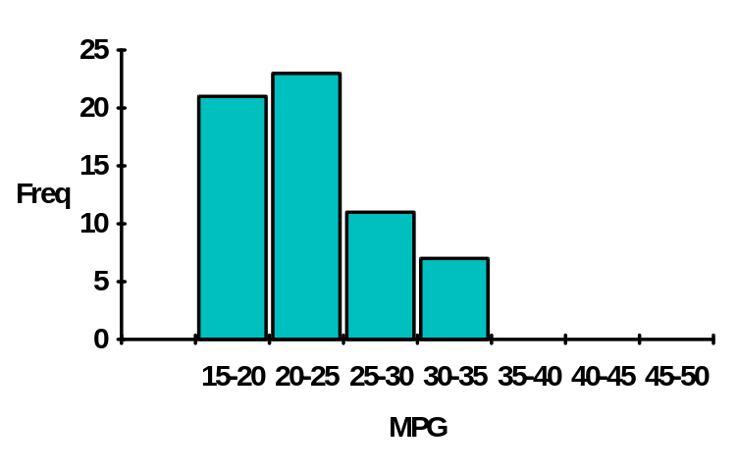

European Cars:

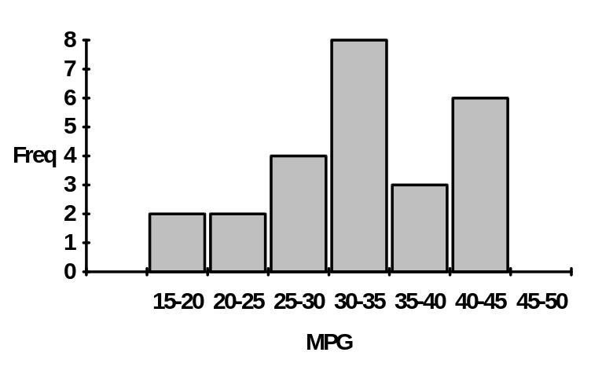

NOTE : To aid comparison the x -axes (the horizontal one) are all the same.
Construct the histogram for the Japanese cars.
List your observations that can be drawn from these displays. How can any differences be explained?


Another type of display, is the cumulative frequency polygon or ogive, which are useful for ordering the data. These are formed by plotting the cumulated frequencies against the interval end points. For the car data they are shown below:

First For The U.S.A.

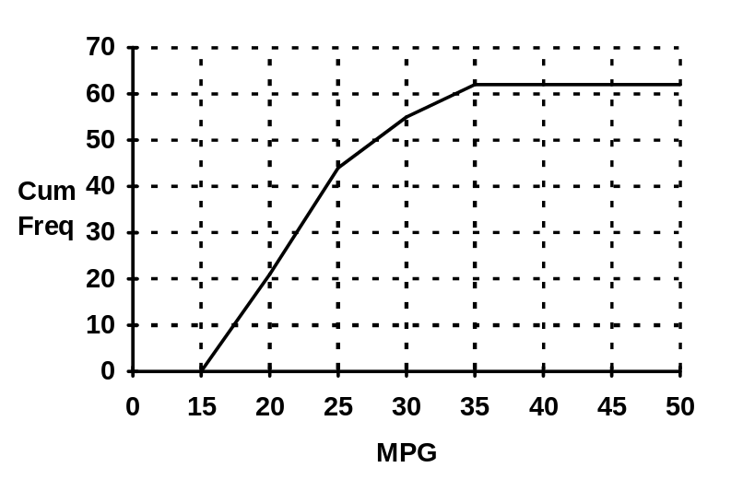

For European cars
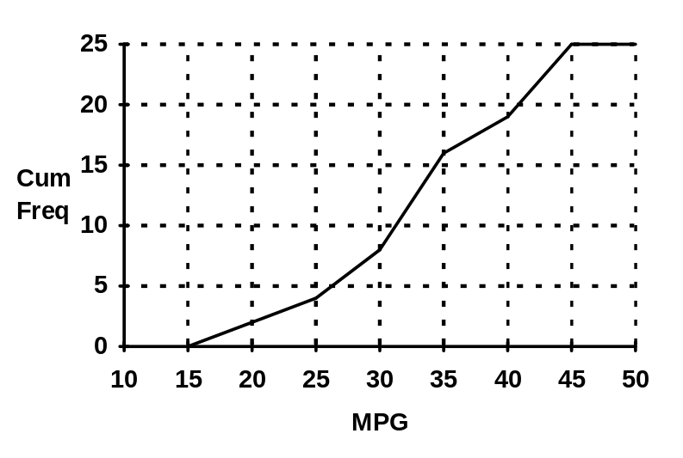

and for Japanese cars
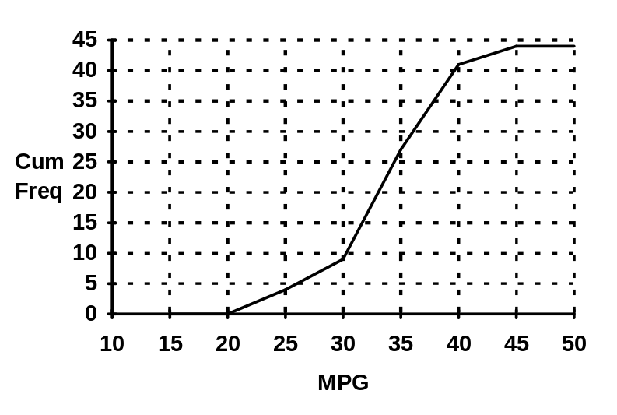

NUMERICAL MEASURES

LOCATION

The MEAN (or arithmetic average,) - this is just the sum of all the numbers divided by the number of numbers. It is written:

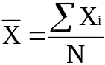

Where sigma means add up and Xi is a typical number and N is the number of numbers.

for example:

10 4 7 5 10 12 8
n = 7
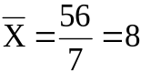

What happens to the average if the next number in the data series is 100?

The MEDIAN - this is the middle number when the numbers are arranged in order of size. For the above example:

4 5 7 8 10 10 12
↑
|
Median

The mean can be changed markedly by extreme observations. If, for example, the next observation in the above series was 50, the mean would be 106/8 = 13.25 - not a very representative number. On the other hand the median is robust (insensitive) to such changes.

That is : 4 5 7 8 10 10 12 50 (an even number so take the average)
↑
9 (median)

Another measure is the MODE or the most common number.

For example:

2 4 7 3 8 3 9 1 2 3 4 8 3

mode = 3

Consider a consumer survey of Biscuit flavour, where consumers are asked to rate biscuits on a scale 1 (very disagreeable) to 9 very agreeable. The results presented on a DOTOGRAM might be :

. .
. .
. . . .
. . . . . .
. . . . . . .
. . . . . . . . .
___________________________________________
1 2 3 4 5 6 7 8 9

This is bimodal, with modes at 3 and 8.

MEASURES OF SPREAD

The most obvious measure of spread is the RANGE which is simply the largest number minus the smallest. For example the range of the numbers :

2 10 13 20 4 7 8 9 9 3 25 20 10 6 6 4 8 10

is 25 - 2 = 23.

Just as the arithmetic mean was distorted by outliers (extreme measurements), so it is with the range. Hence, alternative measures are required when outliers are likely to be present.

The most used measure the STANDARD DEVIATION. This measure is defined as the square root of the VARIANCE, which is a fundamental concept in statistics.

For present purposes the variance, denoted by s2 is thought of as the spread around the mean and is given by the formula:
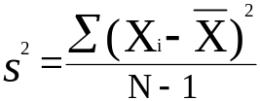

So the standard deviation is simply s.

To find the variance of the set of data measurements:

4 6 5 8 2 ;

First find the mean. (25/5 =5)

Now subtract 5, the mean, from each number to get:

-1 1 0 3 -3

Next, square the numbers:

that is : 1 1 0 9 9

add them up to get 20

Now divide by n - 1, which is 5 - 1 = 4 to get 5 which is the variance, the standard deviation then is 2.236.

As with the mean and the range, the variance can still be distorted by outliers. Consider including 50 in the data set used earlier :

4 6 5 8 2 (50)

The variance and standard deviation now become 341.5 and 18.48 respectively. A more robust measure is the INTER QUARTILE RANGE.

To obtain this measure the data are arranged in order of size and then partitioned into four equal (or near equal) portions, that is:

2 4 5 6 8 50
↑ ↑ ↑
| | |
| | |
Q1 Q2 Q3
(lower quartile) (upper quartile)
(median)

So the inter quartile range is Q3 - Q1 = 8 - 4 = 4 (by chance, it is also 4 if the 50 is not included).

Another often used measure of spread is the semi - inter quartile range, which is :

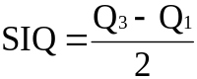

Coefficient of Variation (CV)

This combines the mean as a measure of location and the standard deviation. as a measure of spread to give a unit free measure.

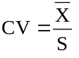

One normally desires this to be a large value, certainly bigger than six. For those with an electronics background it is analogous to the singal to noise ratio.

Outliers

These are values that are not representative of the bulk of the data and as we will see later they can be detected as values that are more than three standard deviations away from the mean i.e.:
X_{i} is an outlier if:

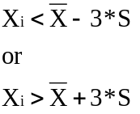

A simpler method of detection is to use the interquartile range i.e. Q₃-Q₁, which is called the hinge spread (HS). X_{i} could possibly be an outlier if it is below:

Q₁ -1.5*HS or above Q₃ +1.5*HS

X_{i} is probably an outlier if it is below:

Q₁ -3*HS or above Q₃+3*HS

It is a good idea to scan data for outliers as they can give a false impression of the data when it is summarised. If the outliers looks to be a mistake or from a different population then it is usually removed (deleted).

The table below gives a numerical statistical summary of the mpg data for the different origins of the cars.

The findings from the pictorial analysis are verified.

Sample Average Median Mode Range
Level size
--------------------------------------------------------------------------------
U.S.A. 85 25.2624 24.3000 27.0000 23.5000
Europe 25 32.5520 33.0000 31.9000 28.1000
Japan 44 33.4795 33.3000 37.0000 25.5000
--------------------------------------------------------------------------------

Variance Standard Lower Upper
Level deviation quartile quartile
------------------------------------------------------------------
U.S.A. 37.4512 6.11974 20.2000 29.0000
Europe 66.9226 8.18062 28.1000 37.3000
Japan 27.8021 5.27277 31.4500 37.0000
------------------------------------------------------------------

NOTE: When comparing two processes at the same time robust measures are best, that is the median and inter quartile range. However, to monitor the same process over time, when one wants to pick up oddities the mean and range are best.

SKEWNESS

Skewness is a problem in statistics and occurs when a distribution of data has long "tails", for example production yields as a percentage of target or annual incomes of the working population, as shown in the diagrams below:

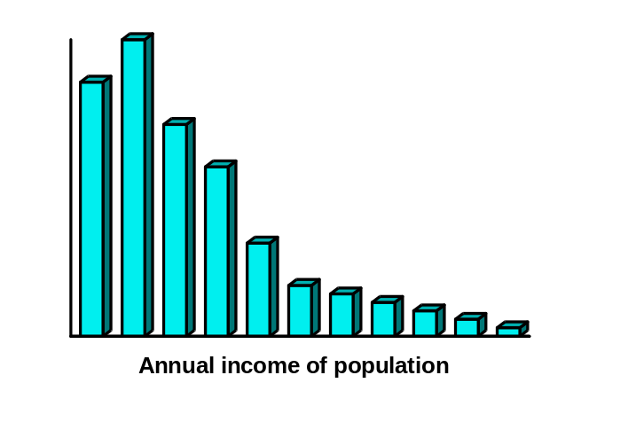

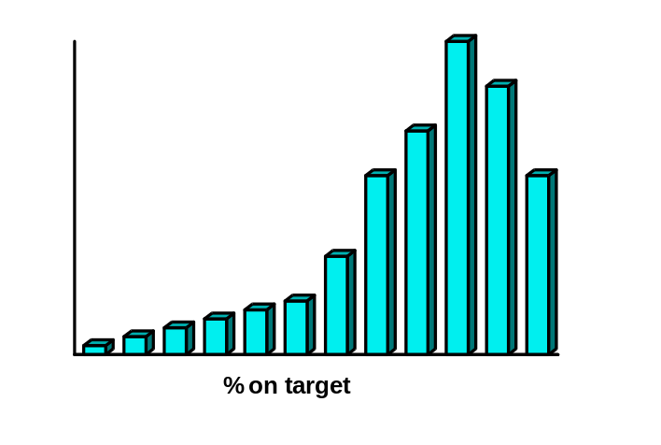

Skewness can be measured by:

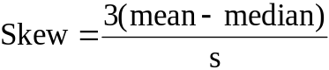

When skewness is judged to be a factor, the mean and standard deviation are unreliable measures, and the median and inter quartile range are better.
EXPLORATORY DATA ANALYSIS (EDA)

This is the name given to a very simple but powerful set of techniques that both visually and numerically describe sets of data.

Consider the following set of delivery costs:

40 38 27 39 36 37 33 31 30
55 59 52 28 36 38 34 35 38
63 52 57 38 26 31 36 60 84
44 41 39 37 37 29 52 38 42

These can be represented in a STEM & LEAF DIAGRAM as shown below:

Working Stem & Leaf
Stem Leaves
2* 7 8 6 9 Leaf Unit = 1
3. 3 1 0 4 1
. = 0-4 3* 8 9 6 7 8 5 8 8 6 9 7 7 8
* = 5-9 4. 0 4 1 2
4*
5. 2 2 2
5* 5 9 7 Leaves are the
6. 0 3 last important
6* digit.
7.
7*
8. 4 - Outlier?

Finished Stem & Leaf
Stem Leaves
2* 6 7 8 9 Leaf Unit = 1
3. 0 1 1 3 4
3* 5 6 6 6 7 7 7 8 8 8 8 9 9
4. 0 1 2 4
4*
5. 2 2 2
5* 5 7 9
6. 0 3
6*
7.
7*
8. 4 - Outlier?

Observations:

There are no delivery costs in the interval 45 to 49. Why?

NOTE : It is easy to obtain the mean and quartiles from this display. Since n = 36, Q1 will be between the 9th and the 10th number, Q2 (the median) is between the 18th and 19th number, and Q3 between the 26th and 27th number. They are:

Q1 = 34.5
Q2 = 38.0
Q3 = 48.0

NOTE: Unlike the histogram, the stem & leaf display preserves all the numbers.

From stem and leaf displays:

- outliers can be identified

- skewness can be identified

- gaps in the data highlighted

- other oddities - for example, the following stem and leaf is of the recordings of a patients’ pulse rate:

4* 8 Leaf unit = 1
5. 22
5* 6666
6. 000000000044444444444
6* 888888888888888
7. 22222222222222222
7* 6666666666666666
8. 0000044444444
8* 88888
9. 222
9*
10. 0

Any comments on the above display?


Two stem and leaf diagrams can be compared back to back, for example American and Japanese car's mpg. This is a very useful display.

Back to back stem and leaf for U.S.A and Japan

U.S.A |  | JAPAN
5 | 1F
7777766 | 1S
9999999988888 | 1o
1000000000 | 2* | 1
333333222 | 2T | 33
55544 | 2F | 45
777777766666 | 2S | 77
99888888 | 2o | 99
11000 | 3* | 1111
322 | 3T | 22222222233
544444 | 3F | 4445
666 | 3S | 66677777
988 | 3o | 88899
 | 4* | 0
 | 4T
 | 4F | 4
 |  | HI 46

The individual stem and leaf diagrams for all the countries are shown on the next page.
Stem-and-leaf display for European Car MPG: unit = 1 1|2 represents 12

2 | 1o | 67
4 | 2* | 01
8 | 2o | 5789
(7) | 3* | 0011344
10 | 3o | 5667
6 | 4* | 013344

Stem-and-leaf display for Japanese Car MPG: unit = 1 1|2 represents 12

 | LO | 21
3 | 2T | 33
5 | 2F | 45
7 | 2S | 77
9 | 2o | 99
13 | 3* | 1111
(11) | 3T | 22222222233
20 | 3F | 4445
16 | 3S | 66677777
8 | 3o | 88899
3 | 4* | 0
2 | 4T
2 | 4F | 4
 | HI | 46

Stem-and-leaf display for USA Car MPG: unit = 1 1|2 represents 12

1 | 1F | 5
8 | 1S | 6677777
21 | 1o | 8888899999999
31 | 2* | 0000000001
41 | 2T | 2223333333
(5) | 2F | 44555
39 | 2S | 666667777777
27 | 2o | 8888899
20 | 3* | 00011
15 | 3T | 223
12 | 3F | 444445
6 | 3S | 666
3 | 3o | 889

Digiplots

These combine the idea of stem and leaf displays with run plots and are useful to reflect the distribution and time series.

Consider the following twenty test scores:

80 85 90 70 75 80 82 73 79 70
50 55 58 59 60 50 53 56 54 50

0 9
5200 8
95300 7
0 6
986543000 5

BOXPLOTS

These are excellent displays of both location and spread and they are very easy to do, especially if the stem and leaf has been done. Consider the delivery cost example:

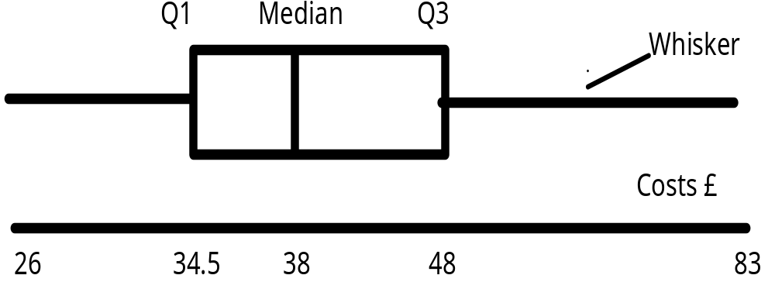

The box contains 50% of the data , so its width is a reflection of spread. Location is shown by the median and skewness by the symmetry of the box.

Boxplots are good for comparing several samples. For example, a comparison is quickly made of the mpg of cars from different origins in the diagram below:
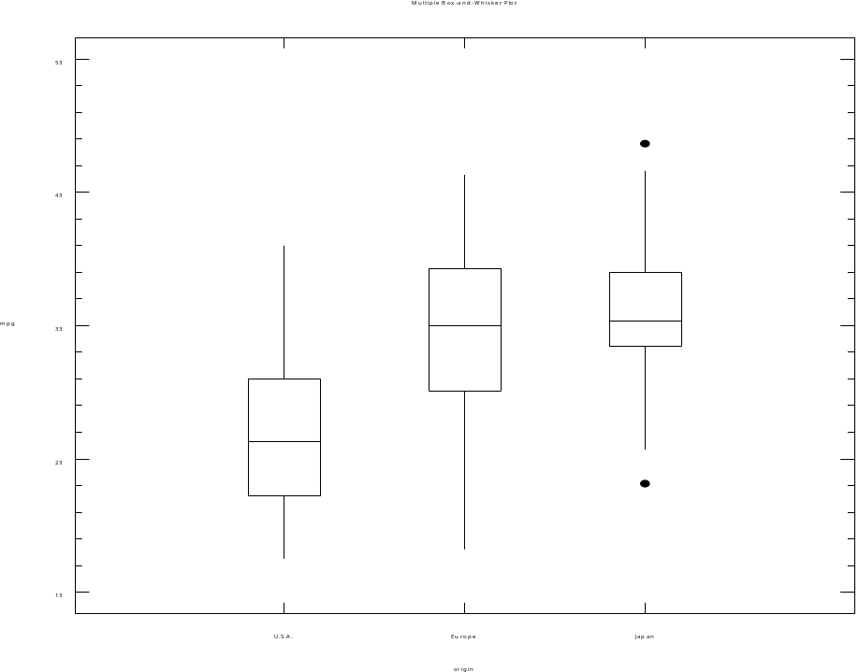

This verifies the earlier findings.

Consider steel sheet being rolled to a target thickness (T) on four different machines:

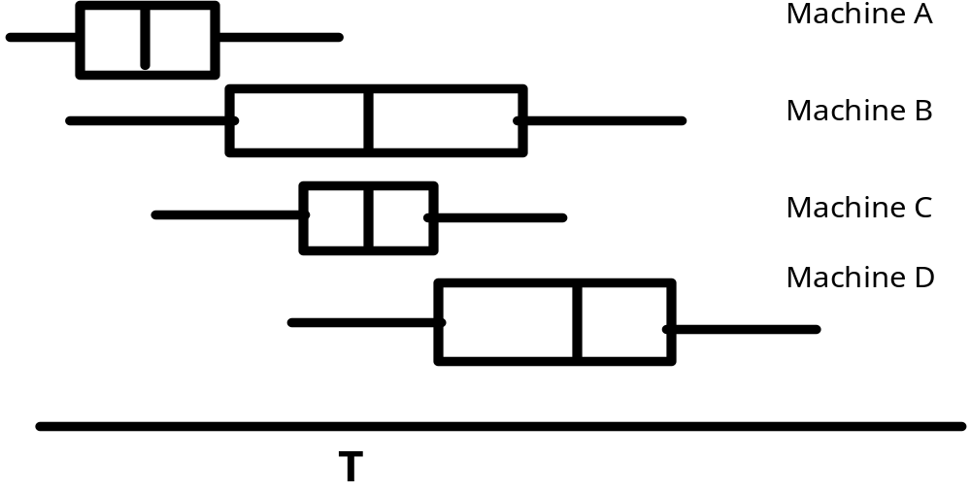
From this display, one observes that:

- Machine A is located well below target relative to the other machines.
- Although on target, machine B displays a great deal of variability relative to the other machines.
- Machine C appears ideal
- Machine D is located too high.
Smoothing

When plotting or otherwise examining data; the data may be very noisey” and a clearer uunderstanding can be obatained if it is smoothed. There are many smoothing methods - the most straight forward is moving averages, in which individual data values are replaced by the average of those around then. This is illutrated in the following table in which a 5 period moving average is used:

Data | 8 | 12 | 7 | 9 | 10 | 50 | 10 | 3 | 14 | 11
MA(5) | - | - | 9.2 | 17.6 | 17.2 | 16.4 | 17.4 | 17.6 | - | -

Note: that the moving average was heavily influenced by the data value 50. The equivelent median smoother is much more robust and gives:

Med(5) | - | - | 9 | 12 | 10 | 10 | 10 | 11 | - | -

Consider the following share prices for IBM:
Variable: TSDATA.ibm (length = 120)
------------------------------------------------------------------------
( 1) 460 ( 19) 487 ( 37) 475 ( 55) 491 ( 73) 523 ( 91) 527
( 2) 457 ( 20) 491 ( 38) 473 ( 56) 492 ( 74) 519 ( 92) 540
( 3) 452 ( 21) 487 ( 39) 474 ( 57) 494 ( 75) 523 ( 93) 542
( 4) 459 ( 22) 482 ( 40) 474 ( 58) 499 ( 76) 531 ( 94) 538
( 5) 462 ( 23) 479 ( 41) 474 ( 59) 498 ( 77) 547 ( 95) 541
( 6) 459 ( 24) 478 ( 42) 465 ( 60) 500 ( 78) 551 ( 96) 541
( 7) 463 ( 25) 479 ( 43) 466 ( 61) 497 ( 79) 547 ( 97) 547
( 8) 479 ( 26) 477 ( 44) 467 ( 62) 494 ( 80) 541 ( 98) 553
( 9) 493 ( 27) 479 ( 45) 471 ( 63) 495 ( 81) 545 ( 99) 559
( 10) 490 ( 28) 475 ( 46) 471 ( 64) 500 ( 82) 549 (100) 557
( 11) 492 ( 29) 479 ( 47) 467 ( 65) 504 ( 83) 545 (101) 557
( 12) 498 ( 30) 476 ( 48) 473 ( 66) 513 ( 84) 549 (102) 560
( 13) 499 ( 31) 476 ( 49) 481 ( 67) 511 ( 85) 547 (103) 571
( 14) 497 ( 32) 478 ( 50) 488 ( 68) 514 ( 86) 543 (104) 571
( 15) 496 ( 33) 479 ( 51) 490 ( 69) 510 ( 87) 540 (105) 569
( 16) 490 ( 34) 477 ( 52) 489 ( 70) 509 ( 88) 539 (106) 575
( 17) 489 ( 35) 476 ( 53) 489 ( 71) 515 ( 89) 532 (107) 580
( 18) 478 ( 36) 475 ( 54) 485 ( 72) 519 ( 90) 517 (108) 584
---------------------------------------------------------------------

------------
(109) 585
(110) 590
(111) 599
(112) 603
(113) 599
(114) 596
(115) 585
(116) 587
(117) 585
(118) 581
(119) 583
(120) 592

The MA (5) smoothed series of IBM shares prices looks like:

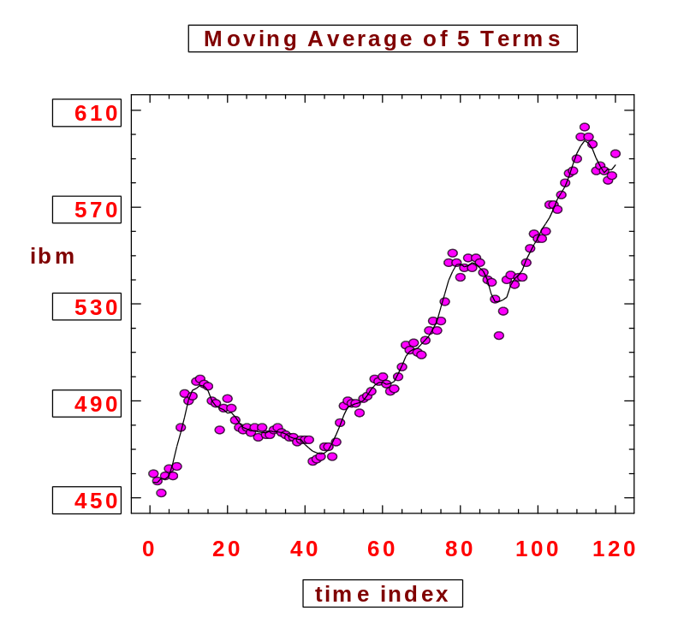

The moving average need not be five a three of seven is sometimes used.

How would you smooth a series of data which was heavily influenced by the month of the year?

